**Interquartile Range (IQR)**

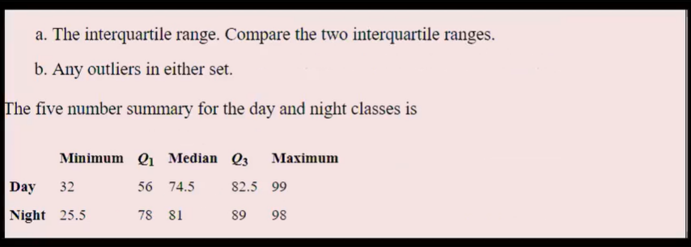

**Day :**

Minimum value of Day=32

Maximum Value of Day=99

Q1 Value of Day =56

Median Of day Q2=74.5

Q3 Value of day=82.5

**IQR:**

IQR=Q3-Q1

IQR of Day=82.5-56=26.5

**Lesser Outlier:**

Lesser outlier= Q1-1.5*IQR

Lesser outlier of Day=56-1.5*26.5

=56-39.75

=16.25

Minimum value of Day is 32 and Lesser outlier of Day is 16.25.So We have Lesser Outlier Present in the Dataset.

**Greater Outlier:**

Greater outlier= Q3+1.5*IQR

Greater outlier of Day=82.5+1.5*26.5

=82.5+39.75

=122.25

Maximum Value of Day is 99 and Greater outlier of Day is 122.25. So We have Greater Outlier Present in the Dataset.

**Night:**

Minimum value of Night=25.5

Maximum Value of Night=98

Q1 Value of Night=78

Median Of Night Q2=81

Q3 Value of Night=89

**IQR:**

IQR=Q3-Q1

IQR of Night =89-78=11

**Lesser Outlier:**

Lesser outlier= Q1-1.5*IQR

Lesser outlierof Night =78-1.5*11

=78-16.5

=61.5

Minimum value of Night is 25.5 and Lesser outlier of Night is 61.5.So We do not have Lesser Outlier Present in the Dataset.

**Greater Outlier:**

Greater outlier= Q3+1.5*IQR

Greater outlier of Night =89+1.5*11

=89+16.5

=105.5

Maximum Value of Night is 98 and Greater outlier of Night is 105.5. So We have Greater Outlier Present in the Dataset.

IQR Value of Day is 26.5 and IQR of Night is 11.IQR Value of the Day is Higher When Compared to IQR Value of the Night.

We have Lesser Outlier of the Day ,Greater Outlier of the Day ,Greater Outlier Of the Night Present in the Dataset.